Title: A Functional Data Analysis of At-Home Activity and Sleep in Klinefelter Syndrome Patients Versus Age- and BMI-Matched Controls

Authors: Samantha Bothwell ^{1,2}, Karli Swenson ¹, Emma Todd ¹, Mia Middleton ¹, Shanlee Davis ^{1,3}

AFFILIATIONS:
- eXtraOrdinary Kids Turner Syndrome Research and Clinic Team, Children’s Hospital of Colorado, Aurora, Colorado.
- Child Health Biostatistics Core, University of Colorado School of Medicine, Aurora, Colorado.
- Division of Endocrinology, Children’s Hospital Colorado, Aurora, Colorado, Department of Pediatrics, University of Colorado School of Medicine, Aurora, Colorado.

Purpose of the study :
Klinefelter syndrome (KS), 47,XXY, is characterized as an additional X chromosome and affects 1 in 600 males. Men with KS have altered testicular development, deficient testosterone levels, and infertility. They are less physically active than other men, have higher BMIs on average, and report higher levels of fatigue. However, there is a lack of research exploring the interaction between sleep and activity among men with KS. The aim of this analysis is to analyze differences in activity and sleep outcomes between KS cases and non-KS age- and BMI-matched controls.

Methods Used :
We recruited males aged 15-27 with a diagnosis of KS and controls with no diagnosis of KS into the Lipids to Energy (LTE) clinical trial. Groups were age- and BMI- matched and participants were excluded if they had a diagnoses of diabetes. Participants wore ActiGraph accelerometers and ActiWare sleep watches for one continuous week while completing daily surveys on activity, sleep, and diet. ActiGraph accelerometers monitor activity including minute-by-minute measures of body position and movement. ActiWare sleep watches monitor minute level time asleep and awake as well as light exposure. The first and last day of wear for each participant were excluded for the analysis.

We implement a function-on-scalar analytic approach to model the difference in activity count and white light exposure over the daily 24-hour period between KS cases and non-KS controls. Minute level data were collected and averaged across the week of data collection within participant. Sleep time measures are summarized as median [IQR] with differences tested with Kruskal-Wallis tests. A type 1 error rate of 0.05 is assumed.

Summary of Results :
Our analysis includes 16 KS and 10 controls aged 18 to 25 with complete activity and sleep watch data over a 7-day time span. The majority of participants are non-Hispanic White (90%). There was no evidence of a difference in age, height, weight, or BMI between cases and controls, indicating successful matching. Non-KS controls are evidenced to be significantly more active than KS controls from 4 am to 9 pm, with their most active time periods being 8 am and 6 pm (Figure 1A). KS cases are evidenced to be significantly more active, while only about 3 more units on average, compared to non-KS controls from 9 pm to midnight. There was not, however, sufficient evidence to conclude that KS cases went to bed later than non-KS controls. Without accounting for the specific day of the week, KS cases slept longer than non-KS controls, though not significantly so, (median [IQR] : 7.9 hrs [6.7, 9.1] vs 7.5 hrs [6.8, 8.3]; p = 0.055) and got out of bed significantly later (median [IQR] : 9:03 AM [7:27 AM, 9:51 AM] vs 7:37 AM [6:33 AM, 8:21 AM]; p = 0.03). When modeling over the 24-hour day period, controls have a significantly higher amount of white light exposure from 8 am to 9 pm (Figure 1B).

Conclusions :
Our data demonstrate that adolescent males with KS exhibit lower levels of activity during most of the day compared to age- and BMI- matched controls. Additionally, those with KS are sleeping more throughout the day and waking up significantly later than controls. These findings on sleep appear to relate to their exposure to light, as those with KS are exposed to significantly lower levels of light throughout the day, and are reflective of the self-reported fatigue experienced by adolescents with KS. The understanding that adolescents with KS experience greater fatigue and may require increased sleep is pertinent knowledge for caretakers. Further analyses will introduce self-reported measures of fatigue and activity for these adolescents, and will investigate the relationship between sleep and activity on quality of life outcomes.

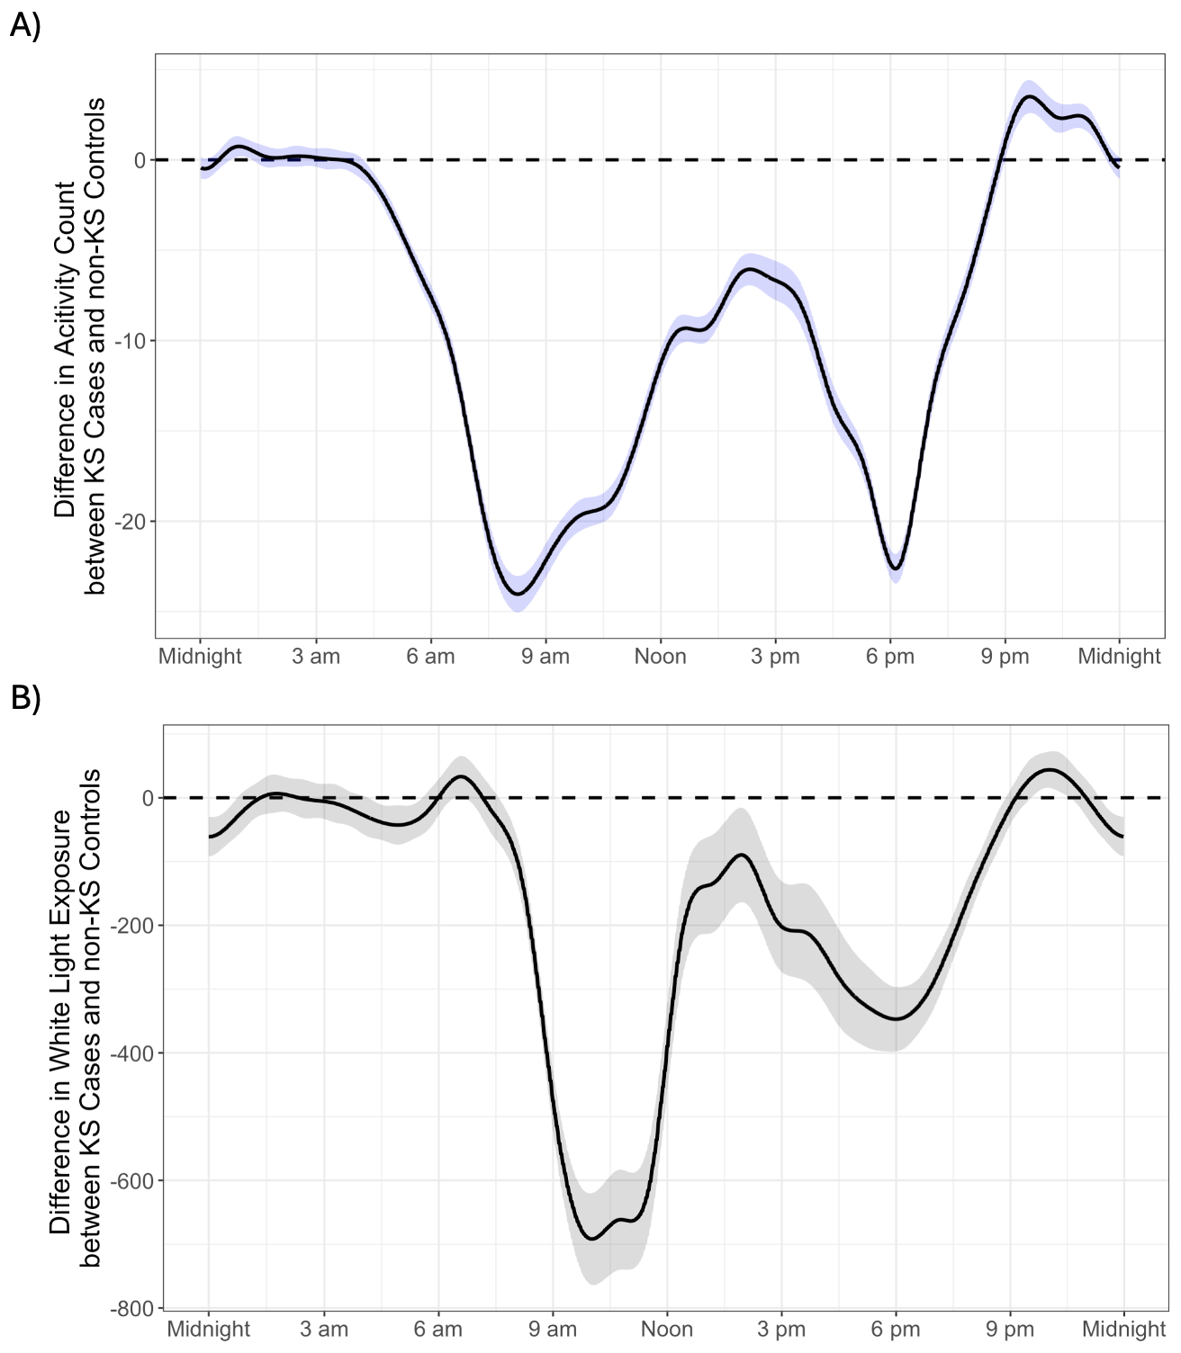
Figure 1.
A ) Function-on-scalar regression beta coefficient for the difference in activity count between KS Cases and non-KS Controls throughout a 24-hour period. Negative values indicate higher activity in non-KS controls while positive values indicate higher activity in KS cases. The blue shaded region represents the 95% confidence interval.
B ) Function-on-scalar regression beta coefficient for the difference in white light exposure between KS Cases and non-KS Controls throughout a 24-hour period. Negative values indicate higher amounts of white light in non-KS controls while positive values indicate higher amounts of white light in KS cases. The grey shaded region represents the 95% confidence interval.

